# CS 255 System Design Document Melissa Chessa

## UML Diagrams

### UML Use Case Diagram

*[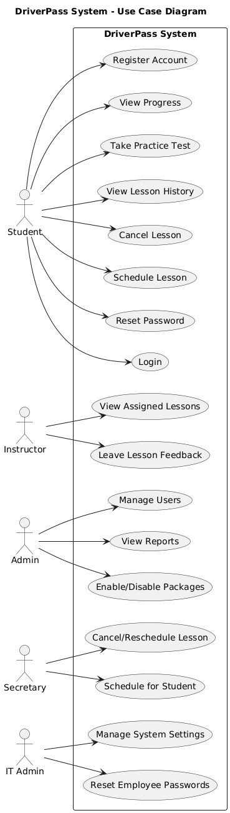]*

### UML Activity Diagrams

*[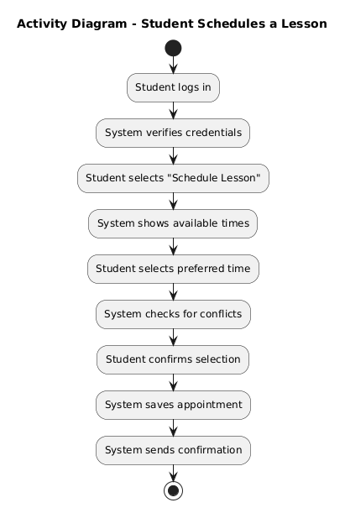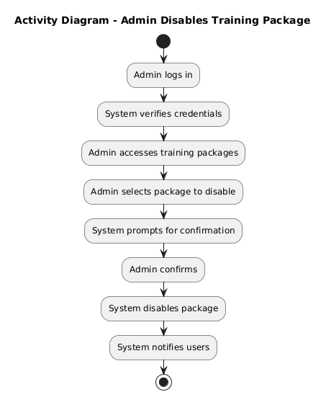*

### UML Sequence Diagram

*[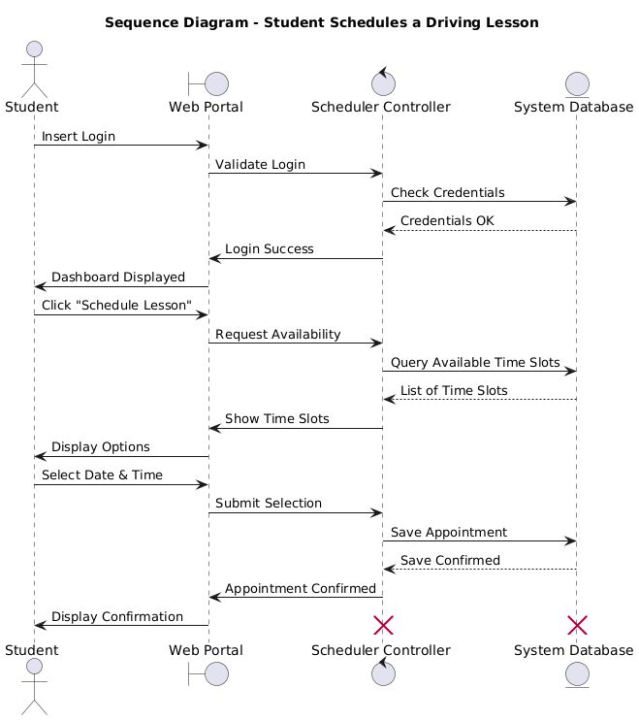*

### UML Class Diagram

*[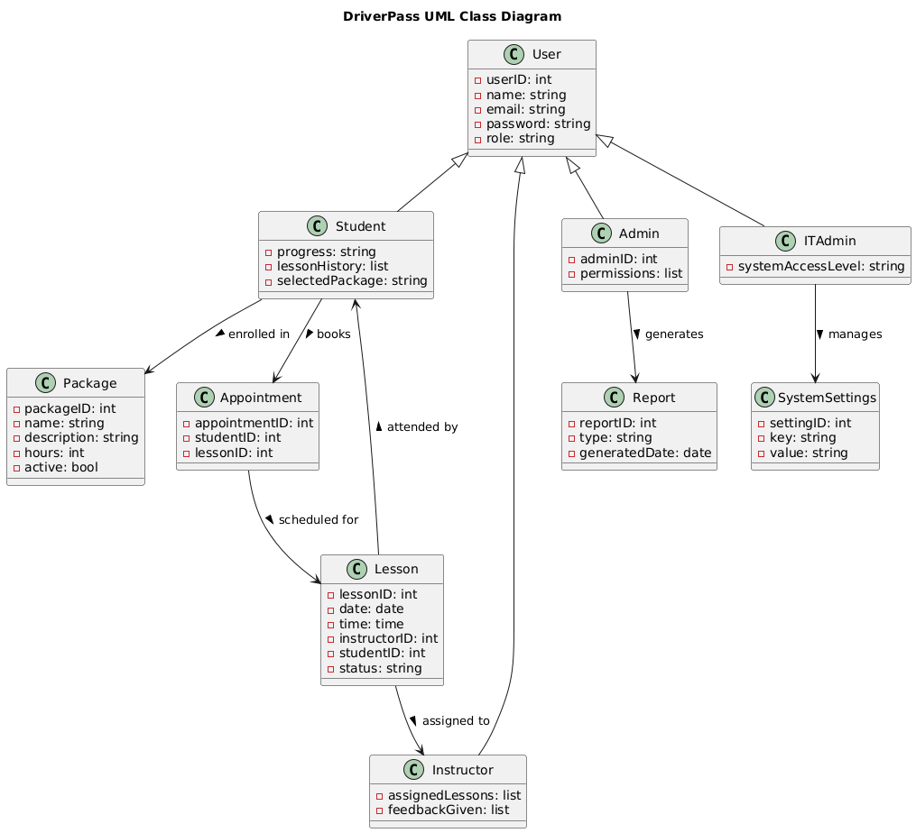.]*

## Technical Requirements

* The system will be web-based and cloud-hosted, accessible from both desktop and mobile devices (Windows, macOS, iOS, Android).
* Users will interact with the system through modern web browsers (e.g., Chrome, Firefox, Safari, Edge).
* A cloud-based database will store user data, lesson history, appointments, and progress tracking.
* The backend will support secure API integration for DMV updates and third-party services (e.g., payment processing).
* No support is planned for legacy systems or proprietary platforms.
* Performance benchmarks include:
  + Page loads, data retrieval, and form submissions must respond within 10 seconds.
  + Weekly updates will be implemented for content, bug fixes, and DMV changes.
* Security features include:
  + SSL/TLS encryption for all client-server communication.
  + Role-Based Access Control (RBAC) to define permissions for students, instructors, admins, secretaries, and IT staff.
  + Case-sensitive credentials with auto-lockout after three failed login attempts.
  + Password reset functionality via email for users and manually for employees by IT Admins.
* Admins can add, disable, or modify user accounts without code changes.
* IT Admins will have full system access, including password resets and system settings management.
* Users will be able to download reports (PDF or CSV), but data modifications require online access to prevent duplication.
* The system is built using scalable technologies to adapt to future browser and device updates.
* A cloud hosting provider will manage server maintenance, backups, and infrastructure-level security.]